UniBot

Sr. Nano Knights

# Team Members:

# Senthil Arasu J Sahithian T R Muhammad Fayaazullah F

# Mentored by Mrs. Priya V

# From:

Vels Vidyashram

No.54, Darga Road, Pallavaram, Chennai, Tamil Nadu 600117  
India

# India Flag Design Waving Indian Flag Made Of Satin Or Silk Fabric Vector Illustration Stock Illustration - Download Image Now - iStock

Table of Contents

1. About Us
2. The Need of this Project
3. A Brief about the Project
4. Social Impact
5. Bibliography

About Us

# The Team:

# Muhammad Fayaazullah F

An unofficial app developer with a deep dive into robotics, crafting innovative solutions at the intersection of technology and creativity,

# Sahithian T R

Robotics enthusiast and loves to take part in different adventurous journeys. Key guitarist of his band, “HEXUS”.

# Senthil Arasu J

We have been a team for the past 2 years. We believe that our team is perfectly packed with all the characteristics necessary for winning. We have participated in various competitions and challenges, with which we have evolved to this stage with a lot of learning and experience. We are from a big state with varieties of diversity among our people, which is Tamil Nadu, speaking the one of the most ancient language in the world, Tamil. We have built our team structure such that it is ensured that all tasks reach the right hands with the right skill. We have split up each of the jobs in way that it is done most efficient as well as quicker. We believe that our team unity is the best of all others, in all the ways.

UniBot

# What is UniBot?

UniBots are tiny wireless robots which are capable of very small movements. When a UniBots is single or individual, its uses are very limited. But when it joins with rest of its pals, it becomes an unimaginable power, with the only limitation of our imagination.

# What can UniBot do?

UniBot is completely different from other robots since it falls into the category of self-assembling robots. It can form various structures through which it can drag, lift, push, pull or move objects easily. Since, UniBot is a shapeshifting robot, it can be used intensively in both industrial and everyday activities. Through this, we can solve various problems with one solution, for example, Moving containers, construction works, Transportation, Assembly line robots, etc. UniBot can also be used to assist or help elderly or handicapped people. UniBot proposes, efficient, sustainable, durable, effortless, convenient use of technology with enormous benefits for all sections of the society.

# Importance of UniBot

As we have seen, UniBot is a complete all in one robot capable of delivering anything that we want. It stands as a solution for various challenges that we face in the world and society, in a very economical and energy efficient manner. The name UniBot comes from its unity. At their core, these remarkable machines embody the concept of autonomous construction, drawing inspiration from the self-organizing properties observed in natural systems, such as cellular organisms. By harnessing the power of artificial intelligence, advanced materials science, and decentralized control algorithms. these machines not only perform predefined tasks but also exhibit emergent behaviours, adaptability, and resilience in dynamic environments.

# Key Features of UniBot

* Completely Wireless – Wi-Fi Communication
* Can be controlled via different remote systems like Neuralink or AI
* Sustainable energy source – Solar power, Causing no harm to Earth
* AutoDock – Automatic wireless charging docking
* Different/customized versions of UniBot – According to the needs of the usage fields.

UniBot - Synopsis

# Introduction

UniBot possess the immense power, technology and structure to transform our world into a simple, quick and effortlessly functioning one. UniBot has been engineered to provide the most beneficial and efficient design ranging from exterior design, mechanical design to software design. Most of the swarm robots can form only 2D structure, but UniBot can form and operate 3D structures, making it as a real world functional robot.

# Objective

The main objective of this project is to remove the aspect of robotics that says that robots can move only on fixed axes, making it non-flexible as compared to a human being’s flexibility and movements which brings a barrier that differentiates artificial simulation through robotics from real world organism’s functioning, that is making robots to function on different moving axes, thus making them most flexible and customizable robots that allows us to form any structure and move in any way.

# Inspiration

The main reason or cause of this project is that it is mostly said that “Robots will never be able to simulate the living organisms, Humans.” But we present this project as proof that robotics can not only simulate the living, but also “emulate”. For example, taking a microscopic organism Amoeba. When Amoeba finds a food, it forms a structure called pseudopodia, which are finger like projects which arise from the body of the Amoeba to capture the food. The formation of the pseudopodia in amoeba, raised a thought, is it impossible to do that through the technology that humans have created till date?

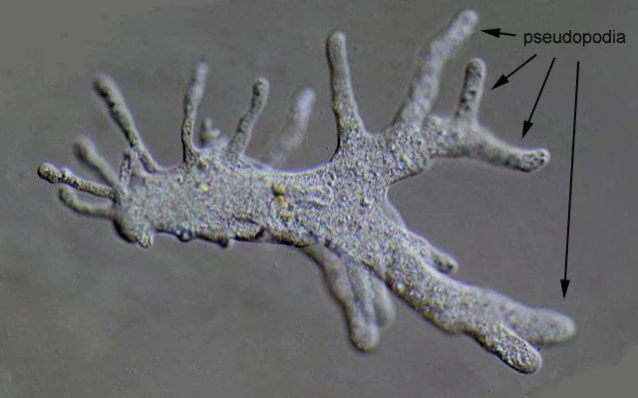

We, Humans our self,are made up of very tiny structures, cells that function together to accomplish a big task. This is the key concept of UniBot and its functioning.

# Social impact & innovation

Self-assembling robots represent a significant leap forward in robotics, with profound potential for social impact and innovation across various fields. Here's a breakdown of their implications:

1. Disaster Response: One of the most immediate applications of self-assembling robots is in disaster response. These robots can autonomously navigate through debris and assemble into structures to aid in search and rescue missions. Their ability to adapt to changing environments and collaborate with each other can significantly improve the efficiency and effectiveness of rescue operations in scenarios such as earthquakes, hurricanes, or industrial accidents.

2. Construction and Infrastructure: Self-assembling robots have the potential to revolutionize the construction industry by automating the assembly of structures. From building temporary shelters in emergency situations to constructing large-scale infrastructure projects, these robots can work collaboratively to reduce construction time, costs, and human labour. Additionally, their flexibility allows for the creation of novel architectural designs that were previously impractical or impossible to build.

3. Healthcare: In the healthcare sector, self-assembling robots can be utilized for targeted drug delivery, minimally invasive surgeries, and even tissue engineering. These robots can navigate through the body, assemble into complex structures, and perform precise tasks with minimal intervention. This technology has the potential to revolutionize medical treatments by improving precision, reducing recovery times, and minimizing the risk of complications.

4. Environmental Monitoring and Conservation: Self-assembling robots can play a crucial role in environmental monitoring and conservation efforts. Equipped with sensors and communication devices, these robots can autonomously navigate through ecosystems, assemble into sensor networks, and collect data on environmental parameters such as temperature, humidity, and pollution levels. This information can be used to monitor ecosystem health, detect environmental threats, and guide conservation initiatives.

5. Space Exploration: In the field of space exploration, self-assembling robots hold promise for autonomous construction of habitats and infrastructure on other planets or moons. By leveraging local resources and autonomously assembling structures, these robots can enable long-term human habitation beyond Earth, supporting scientific research, resource extraction, and colonization efforts.

6. Education and Research: Self-assembling robots also offer valuable educational and research opportunities. By studying their behaviours, interactions, and self-assembly mechanisms, researchers can gain insights into collective intelligence, swarm robotics, and emergent behaviours in complex systems. Moreover, these robots can serve as educational tools to inspire interest in STEM fields and foster creativity and problem-solving skills in students.

Overall, the social impact and innovation potential of self-assembling robots are vast, ranging from disaster response and construction to healthcare, environmental conservation, space exploration, education, and beyond. As research and development in this field continue to advance, we can expect to see increasingly sophisticated applications that address some of the most pressing challenges facing society.